Subject: Programming with Java
Name – Shreya Panda PRN- 25070122181 CSE B3
ASSIGNMENT No: 11
Title
Write a Java program to demonstrate the implementation of interfaces.

Problem Statement
Write a Java program to demonstrate the implementation of interfaces.

Learning Objectives
- To understand the concept of interfaces in Java.
- To implement interfaces for achieving abstraction.
- To demonstrate multiple inheritance of type using interfaces.
- To improve modularity and flexibility in Java applications.

Theory
An interface in Java is a blueprint of a class that contains abstract methods (and constants). It provides 100% abstraction because it only specifies what a class should do, not how it should do it. Any class that implements an interface must provide implementations for all its methods. Interfaces support multiple inheritance of type, allowing a class to implement more than one interface. They improve code reusability, loose coupling, flexibility, and maintainability, making them widely used in enterprise application development.

Outcome
- Understood the concept and purpose of interfaces in Java.
- Learned how to implement interfaces in different classes.
- Demonstrated abstraction and multiple inheritance of type using interfaces.
- Improved knowledge of modular and flexible object-oriented programming.

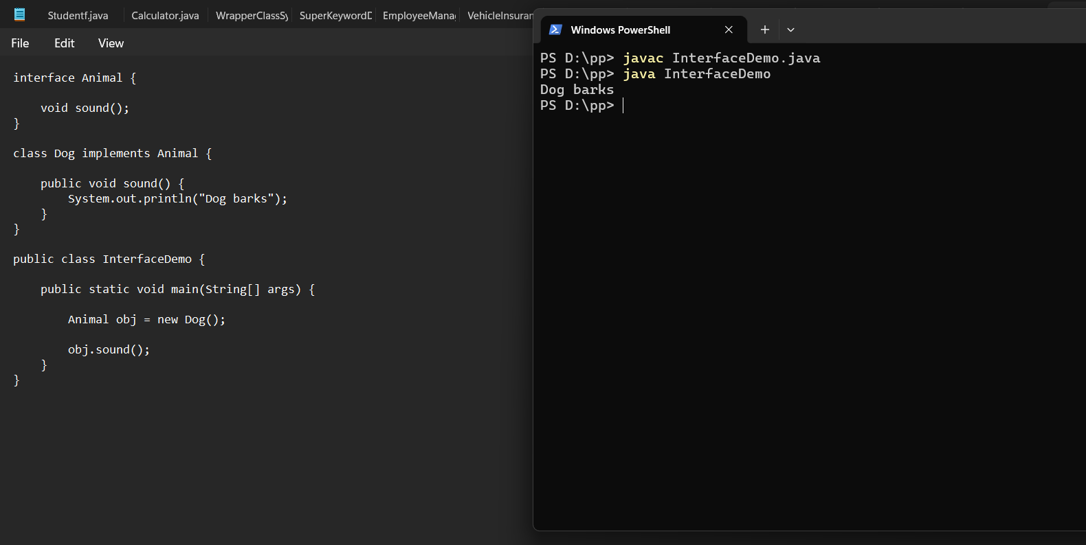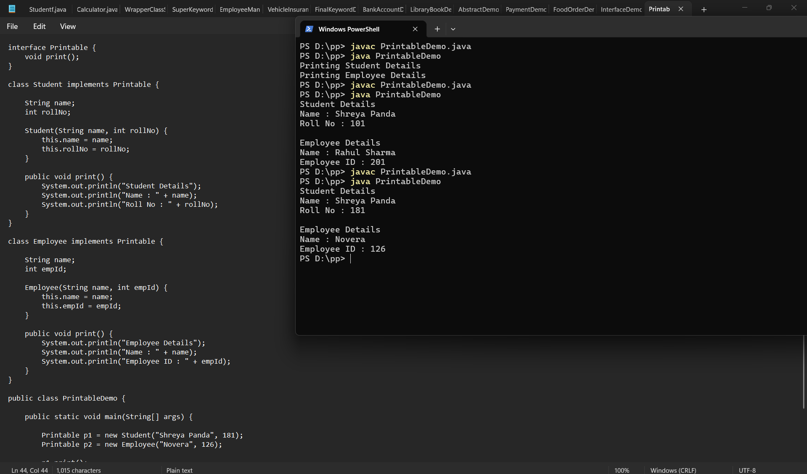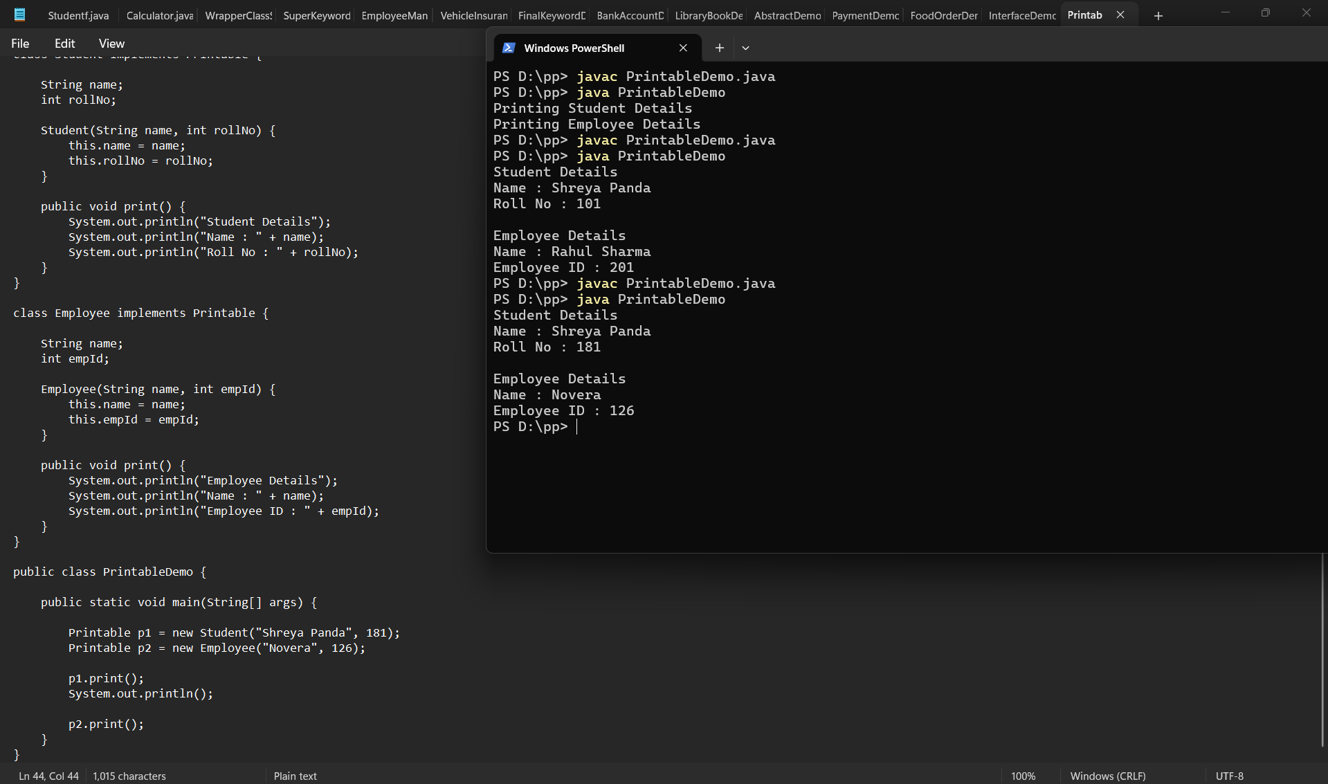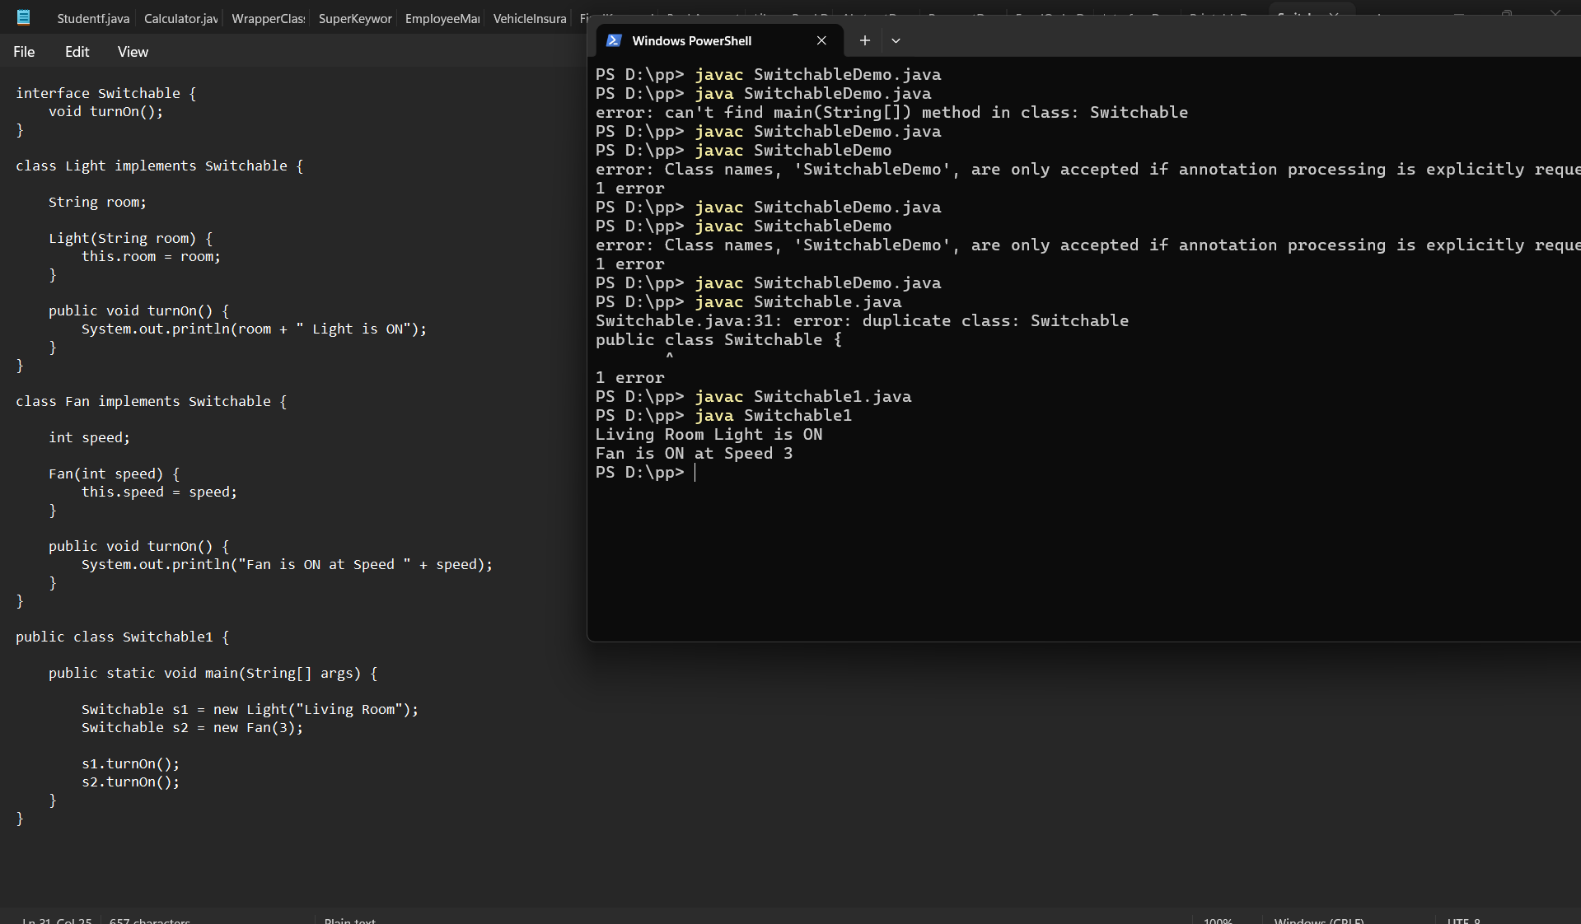

Conclusion
This assignment demonstrated the implementation of interfaces in Java. It showed how interfaces define common behavior while allowing different classes to provide their own implementations. Interfaces promote abstraction, code reusability, flexibility, and loose coupling, making Java applications more maintainable and scalable.

